Remote Mobile Test – Information for research participants

Purpose of the study

Somerset County Council and the four Somerset District Councils are merging to become one Unitary Authority on 1 April 2023. As part of this, a whole new website is being built and we want this to be a great experience for users. We are currently testing the user journey with Somerset residents to ensure they can find the information and services they need. This will help us to make improvements to our website.
What to expect
Usability tests will normally be planned for up to 60 minutes.
To inform the project, during the session we will be asking questions and making notes of the discussion, as well as observing participants complete tasks on the website. This helps us understand what works well for you and what you find useful.
Participants will share their screen (additional instructions attached if needed) and sessions will also be recorded to support the process.
Here’s what you’ll need to take part in the test:
• A quiet room where you won’t be disturbed
• A reliable wifi connection
• A computer
• Your mobile device (your computer and mobile must be on the same wifi network)
• A camera (external or built into your computer)
• Headphones (personal choice depending on your environment)
• And a microphone (your computer mic or headphone mic is fine)
For testing on mobile we will also require you to install free software ‘LetsView’ onto you mobile and desktop. This free app enables you to mirror your mobile screen to your computer screen. Please note you’ll need to download LetsView on both your computer and your mobile phone. Please, if possible, do this ahead of the scheduled session.
For your phone
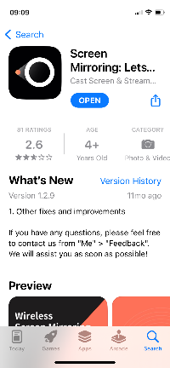
To download the app on your phone - Go to the app store/ Android store and download lets view on your phone. Alternatively click here for Android or click here for iphone.

For your computer
To download the app on your computer – click here
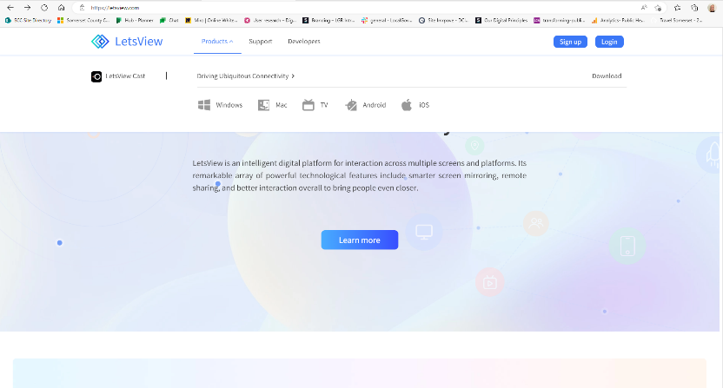

Using the software to share your mobile screen for the test
For detailed instructions on installing LetsView and mirroring your mobile screen for the test, please click here.
Session recordings
If you give us permission on your consent form, we will record the session using audio or video. A researcher will also observe and take notes during the session.
Sharing of results
We will not include your name or personal details in any reports we share or publish. All your information will remain private.
With your permission, the only people who will be able to see the full recordings are:
- Researchers within the Digital Services team.
We may also:
- share highlight recordings with the wider digital team
- make the anonymised findings from this research public so that others can use and learn from it

What happens to the data provided
The information you provide during this study is the research data. Any research data from you which can be identified as being about you is known as personal data. The team will analyse data to inform service innovations within the Council. Anonymised data may be seen by authorised individuals to share research outcomes.
All data is stored in line with SCC’s policies and on our secure servers. For more information about our GDPR regulations, including how data is held and processed, visit our Privacy notices and cookies webpage: https://www.somerset.gov.uk/our-information/privacy-notices-and-cookies/
The research data will be stored for 1 year from the date the project finishes.
Data Protection
Somerset County Council is the data controller with respect to your personal data (registration Z5957592), and as such will determine how your personal data is used in this study. The Council will process your personal data for the purposes of the research outlined above and relies on Article 6(1)(a) - Consent - as the lawful basis for processing and on Article 9(2)(a) - explicit consent - for any special category data collected. Your data will be stored as described and will not be transferred abroad. You have a number of rights in relation to the data we hold about you. For more information see - https://www.somerset.gov.uk/our-information/your-rights-on-the-information-we-hold-about-you/
Taking part is voluntary
Your participation is completely voluntary. You are free to change your mind at any time, before, during or after your session.

